**IBM ASSIGNMENT 2**

**PHARMA SALES DASHBOARD**

|  |  |
| --- | --- |
| **Assignment Date** | **28 September 2022** |
| **Student Name** | **DHARINI B** |
| **Student Roll Number** | **953619104009** |
| **Maximum marks** | **2 marks** |

**Task 1:Sales By Customer**

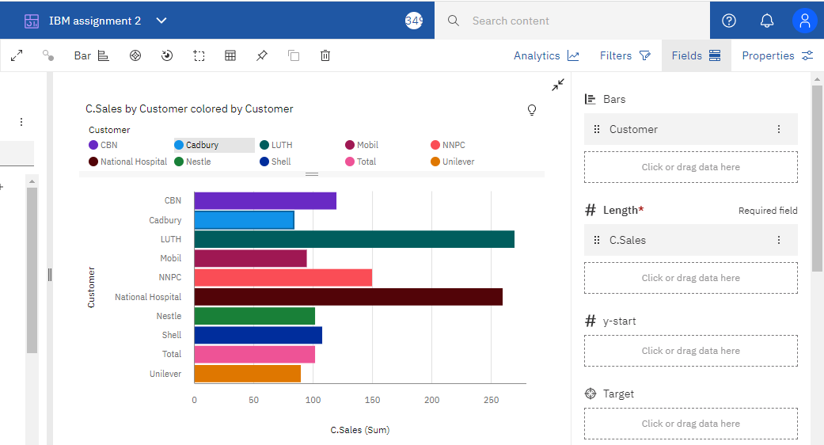

**Task 2:Sales By Location**

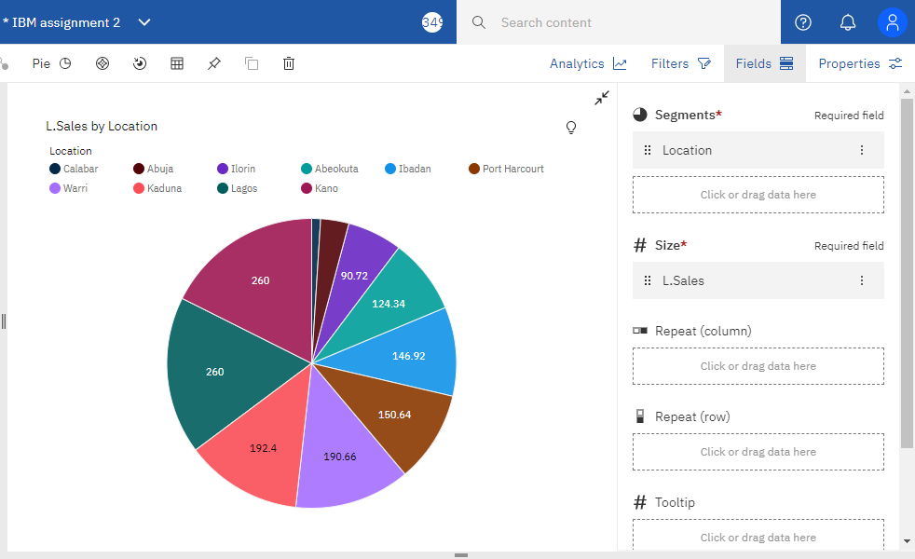

**Task 3:Sales By Sales Representative**

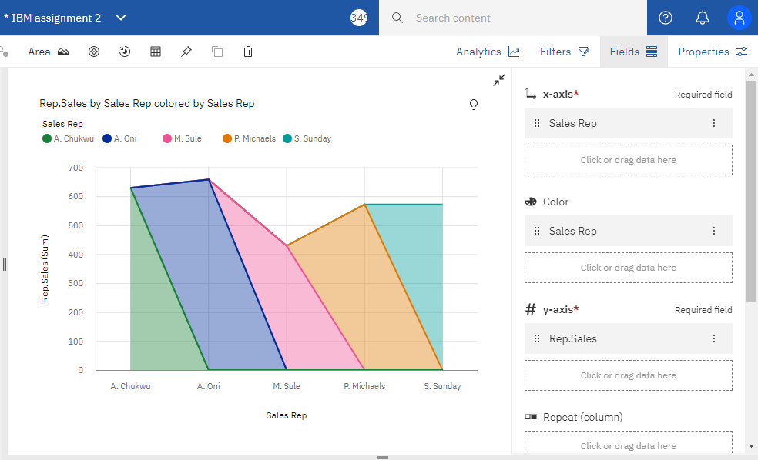

**Task 4: Received Inventory From Supplier**

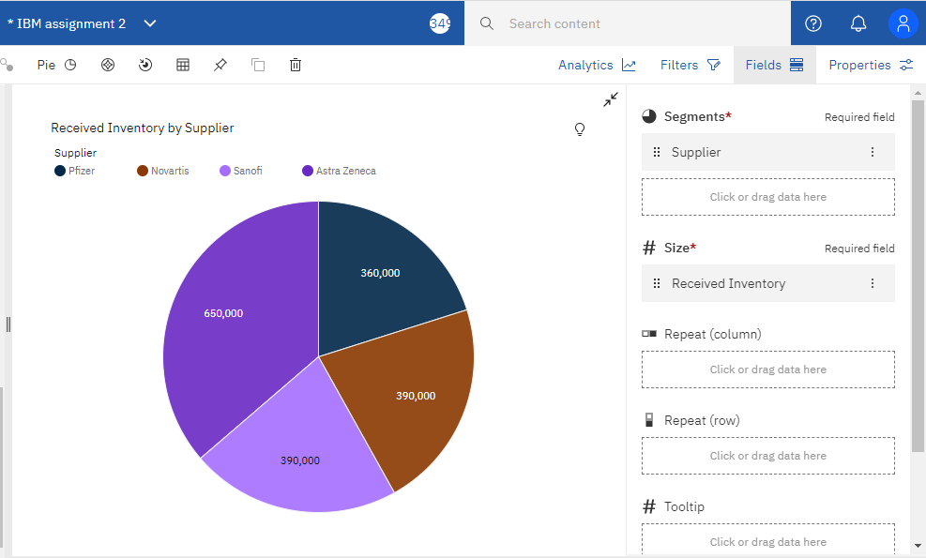

**Task 5: Inventory Stock for Warehouse Locations**

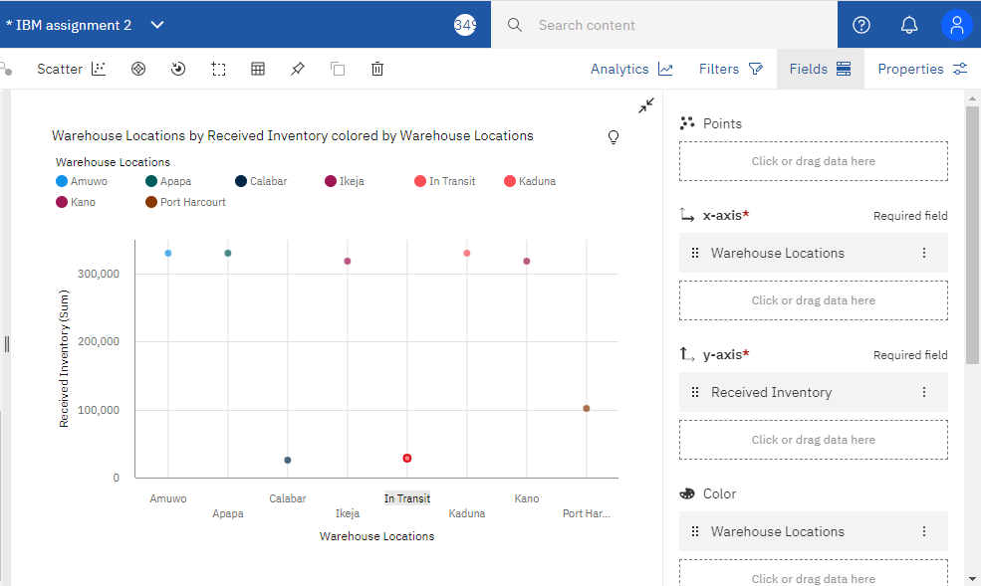

**Task 6: Sales Trend**

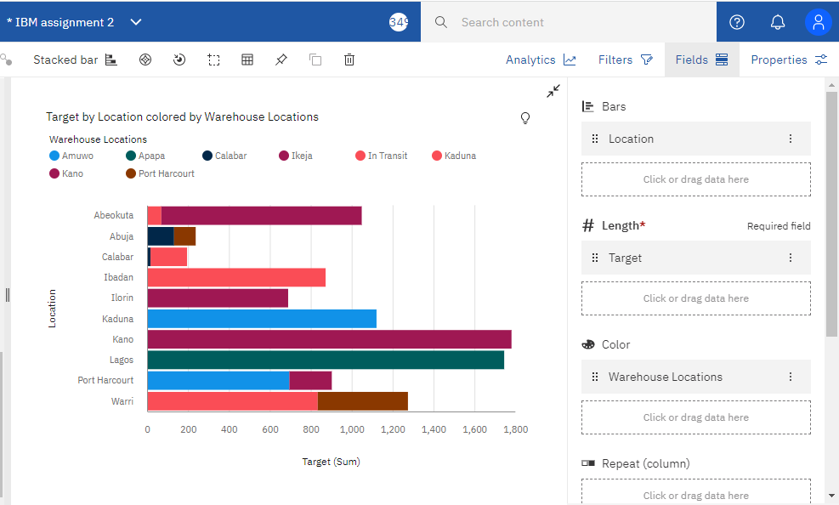

**Task 7:Monthly Sales**

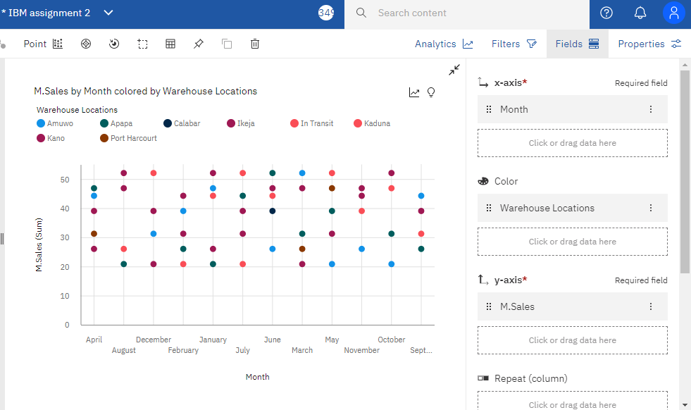

**Task 8: Actual and Received Inventory by Month**

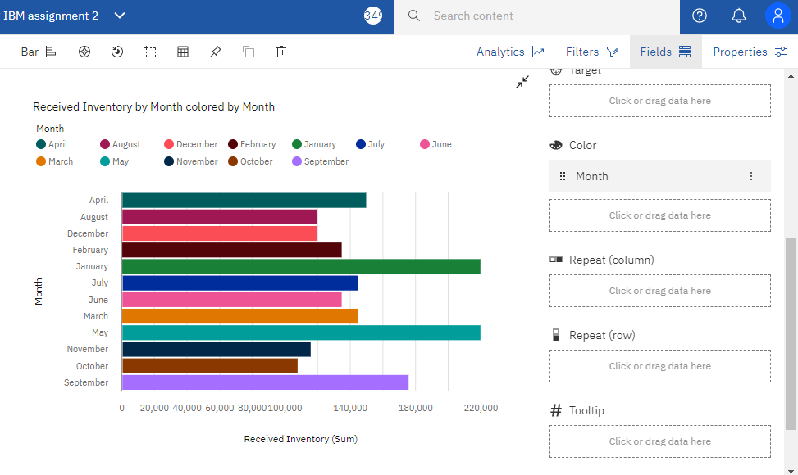

**Link Dashboard:**

[**https://us3.ca.analytics.ibm.com/bi/?perspective=dashboard&pathRef=.my_folders%2FIBM%2BAssignment%2FIBM%2Bassignment%2B2&action=view&mode=dashboard&subView=model0000018386dcc0dd_00000003**](https://us3.ca.analytics.ibm.com/bi/?perspective=dashboard&pathRef=.my_folders%2FIBM%2BAssignment%2FIBM%2Bassignment%2B2&action=view&mode=dashboard&subView=model0000018386dcc0dd_00000003)